ASCII CODE TO HEX CODE CONVERSION

AIM:
To write an assembly language program to convert an array of ASCII codes to corresponding binary (Hex) value in 8085 Microprocessor

APPARATUS REQUIRED:
- 8085 microprocessor kit 1
- Power card 1
- Keyboard 1

ALGORITHM:
- Get the ASCII data in A register from 4200H
- Subtract 30H from A-register
- Compare the content of A-register with 0AH
- If CY = 1 go to step 6. If CY = 0, go to next step
- Subtract 07H from A-register
- Store the HEX into 4202H
- Stop the program
Output:

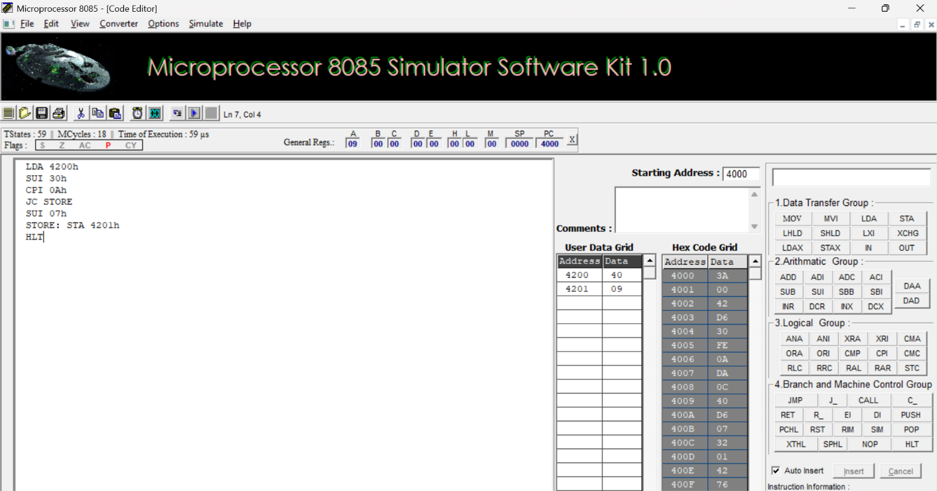

RESULT:
Thus, an assembly language program for converting ASCII to HEX of given 8-bit number was written, executed and Verified the Result successfully using 8085 kit.

